EXPERIMENT – 5

Performing Various Configurations of IPTables Firewall in Kali Linux

Aim
To perform and analyze various firewall configurations using IPTables in Kali Linux to control network traffic and enhance system security.

Software Requirements
- Host Operating System: Windows / Linux / macOS
- Virtualization Software: Oracle VirtualBox
- Guest Operating System: Kali Linux
- Firewall Tool: IPTables
- System Requirements:
  - RAM: Minimum 4 GB (8 GB recommended)
  - Disk Space: Minimum 30 GB
  - Processor: Intel/AMD with Virtualization support

Introduction
IPTables is a powerful firewall utility in Linux used to configure rules for filtering incoming and outgoing network traffic. It operates by defining rules based on IP addresses, ports, and protocols. Configuring IPTables helps protect systems from unauthorized access, network attacks, and malicious traffic. Kali Linux provides built-in support for IPTables, making it suitable for learning firewall configurations in a controlled environment.

Procedure

Step 1: Start Kali Linux Virtual Machine
- Open Oracle VirtualBox.
- Start the Kali Linux virtual machine.
- Log in using Kali credentials.

Step 2: Open Terminal and Check IPTables
- Open Terminal in Kali Linux.
- Check IPTables version:
- iptables --version

Step 3: View Existing Firewall Rules
- Display current IPTables rules:
- sudo iptables -L

Step 4: Set Default Policies
- Set default policy to drop incoming traffic:
- sudo iptables -P INPUT DROP
- Allow outgoing traffic:
- sudo iptables -P OUTPUT ACCEPT

Step 5: Allow Localhost Traffic
- Allow loopback interface traffic:
- sudo iptables -A INPUT -i lo -j ACCEPT

Step 6: Allow SSH Access
- Allow SSH connections on port 22:
- sudo iptables -A INPUT -p tcp --dport 22 -j ACCEPT

Step 7: Allow HTTP and HTTPS Traffic
- Allow HTTP traffic:
- sudo iptables -A INPUT -p tcp --dport 80 -j ACCEPT
- Allow HTTPS traffic:
- sudo iptables -A INPUT -p tcp --dport 443 -j ACCEPT

Step 8: Block a Specific IP Address
- Block traffic from a specific IP:
- sudo iptables -A INPUT -s 192.168.1.100 -j DROP

Step 9: Save IPTables Rules
- Save the configured rules:
- sudo iptables-save > firewall_rules.txt

Output
- Firewall rules are successfully applied.
- Network traffic is filtered based on configured IPTables rules.
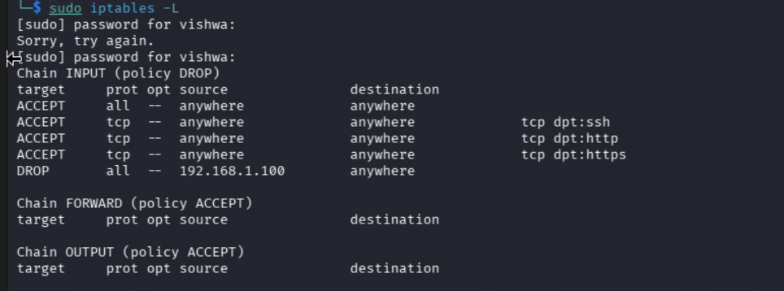

Result
Various firewall configurations were successfully implemented using IPTables in Kali Linux.
The experiment demonstrates how firewall rules can be used to control network traffic and improve system security.

Reference
https://www.kali.org/docs/networking/iptables/

⚠️ Note
This experiment is performed only for academic and ethical purposes in a controlled laboratory environment.

